Name : Kasak Patel
Roll No : 05
Sec-Batch : B-B1
ML Lab 5
Aim : To implement K-Nearest Neighbor (KNN) algorithm for Classification and Regression.
Theory :
K-Nearest Neighbor (KNN) is a supervised machine learning algorithm used for classification and regression. It predicts the output of a new data point by finding the K nearest data points in the training dataset using a distance measure such as Euclidean distance.
In classification, the class is decided by the majority class of the nearest neighbors. In regression, the predicted value is usually the average of the nearest neighbors' values.
The value of K affects the performance of the model, so different K values are tested and evaluated using suitable metrics. For classification, accuracy, precision, recall, and F1-score are commonly used, while regression uses MAE, MSE, RMSE, and R². Decision boundaries can also be visualized to understand the classification regions.

Libraries Used
- Pandas & NumPy: Data handling and numerical calculations.
- Matplotlib & Seaborn: Data visualization and graphs.
- Scikit-learn: KNN implementation, data splitting, scaling, cross-validation, and hyperparameter tuning.
- StandardScaler: Standardizes the input features.
- KNeighborsClassifier: Implements the KNN classification algorithm.
- Metrics: Used to evaluate classification and regression model performance.

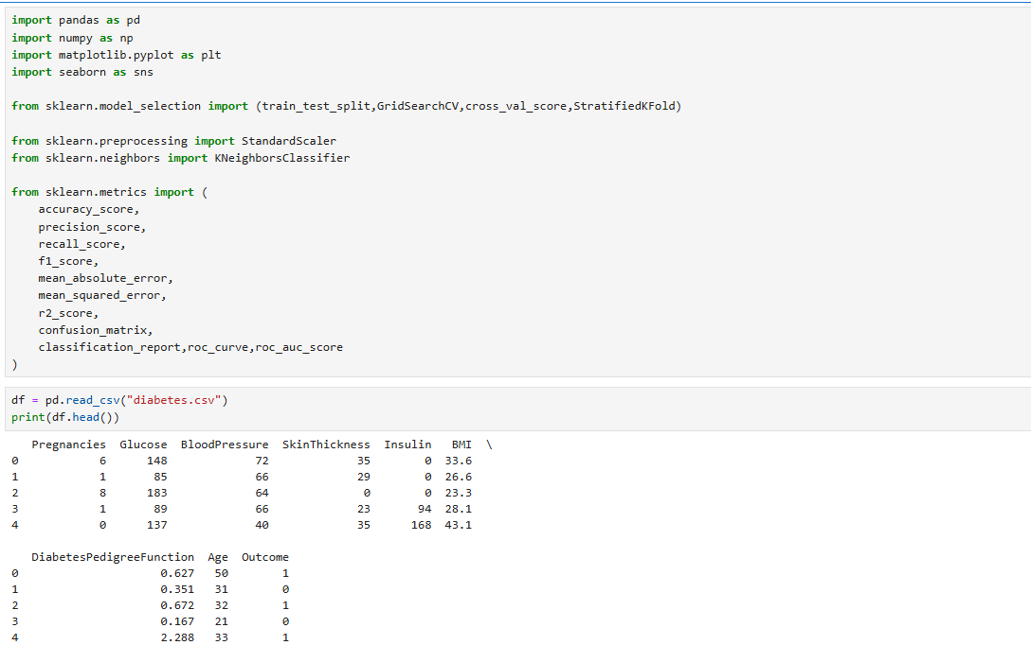

- df.head() – Displays the first 5 rows of the dataset.
- df.tail() – Displays the last 5 rows of the dataset.
- df.describe() – Shows statistical summary such as mean, minimum, maximum, and standard deviation.
- df.isnull().sum() – Counts the missing values in each column.
- df.info() – Shows column names, data types, number of entries, and memory usage.
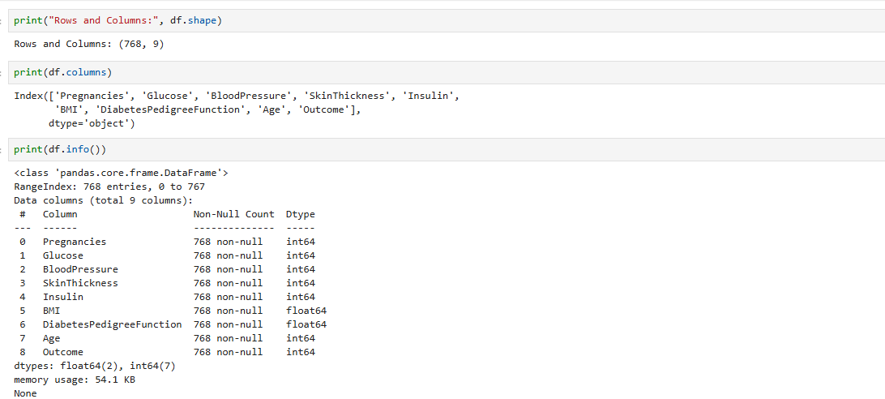

- df.columns – Displays the names of all columns in the dataset.
- df.shape – Shows the number of rows and columns (rows, columns).
- df.duplicated().sum() – Counts the total number of duplicate rows.
- df.value_counts() – Counts the frequency of unique values in a column or Series.
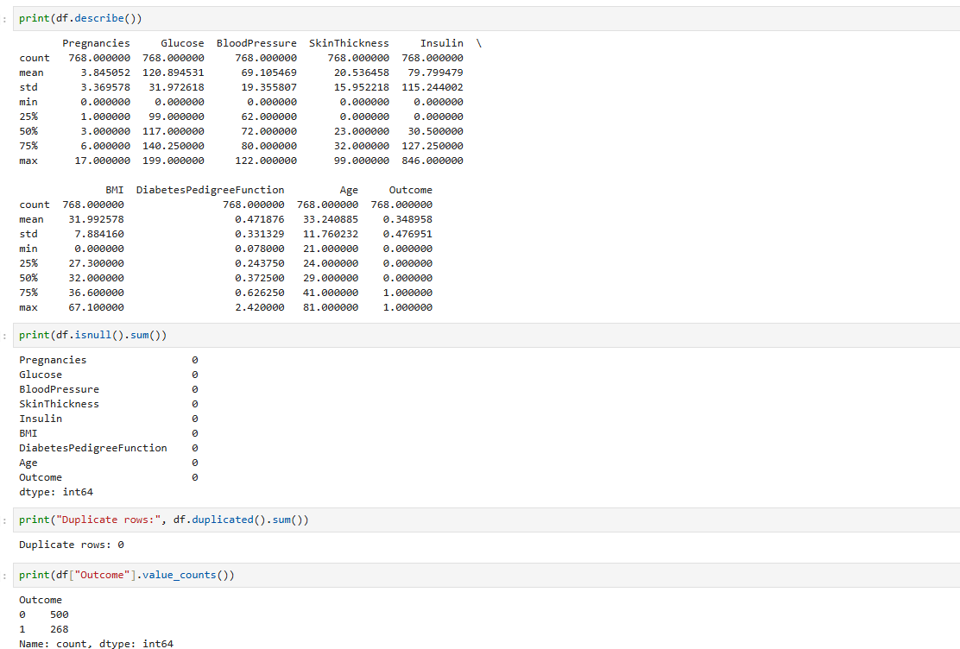

To display the number of diabetic and non-diabetic patients using a bar chart.
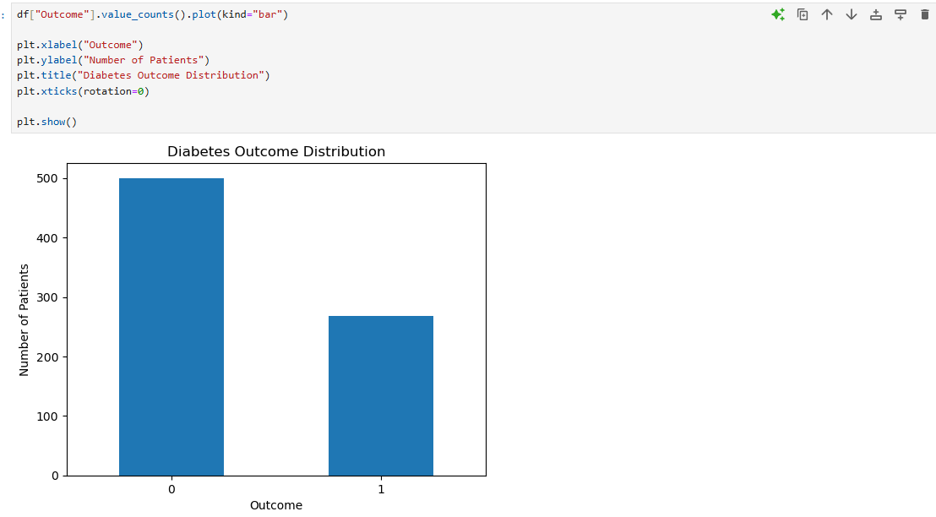To count the number of zero values in selected columns that may represent missing or invalid data.
To calculate and display the correlation of each numerical feature with the Outcome variable.
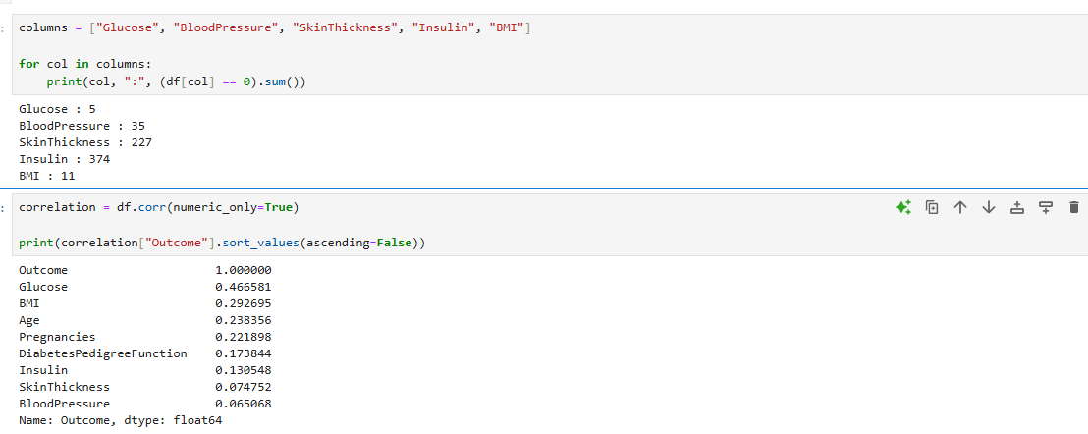To visualize the relationship between Glucose and BMI for the two Outcome classes (0 and 1) using a scatter plot.
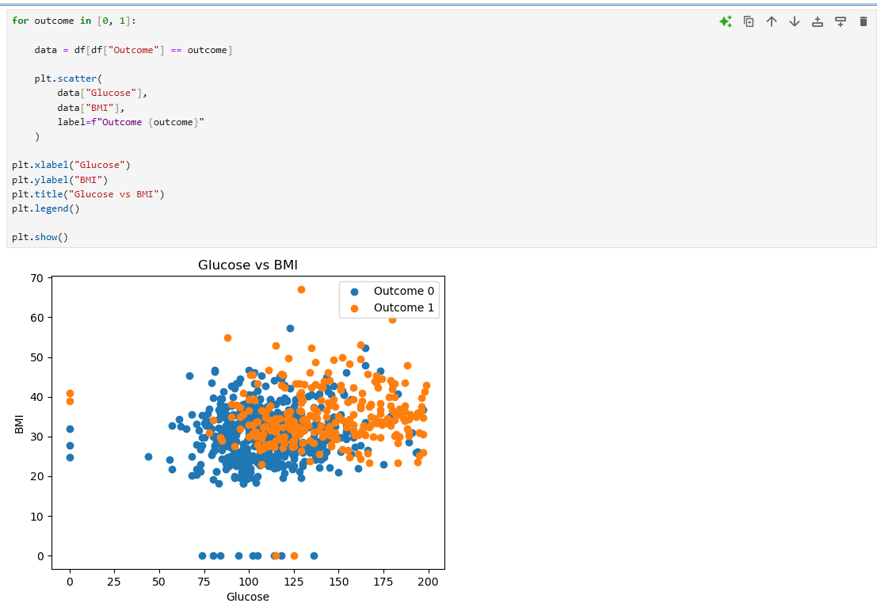
To display a correlation heatmap showing the relationship between all numerical features in the dataset. 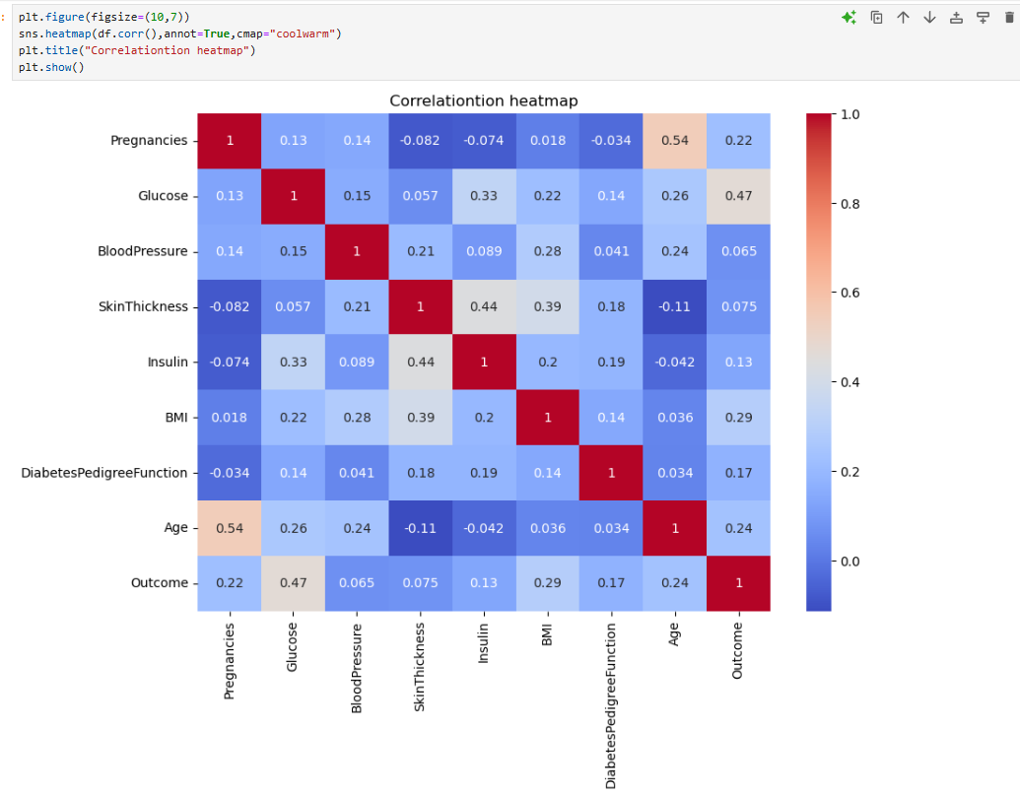
To visualize the distribution of all numerical features in the diabetes dataset using histograms.
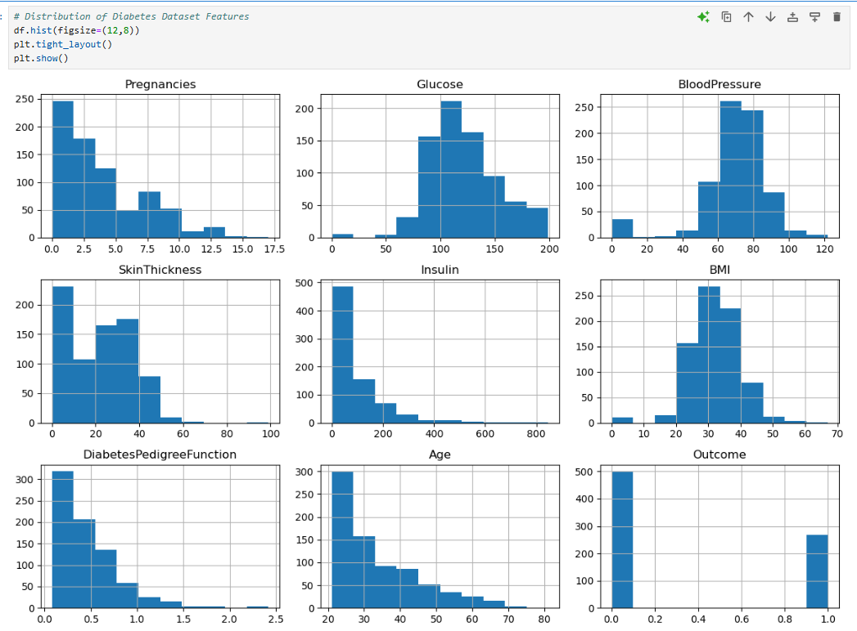
To count the zero values in selected columns that may represent missing or invalid data.
To replace invalid zero values with missing values (NaN) for proper data preprocessing.
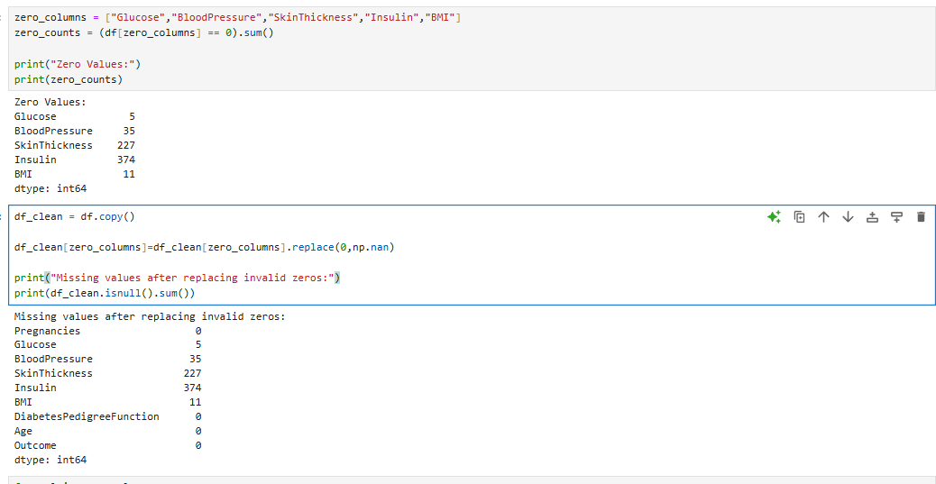
To replace the missing (NaN) values with the median of each selected column
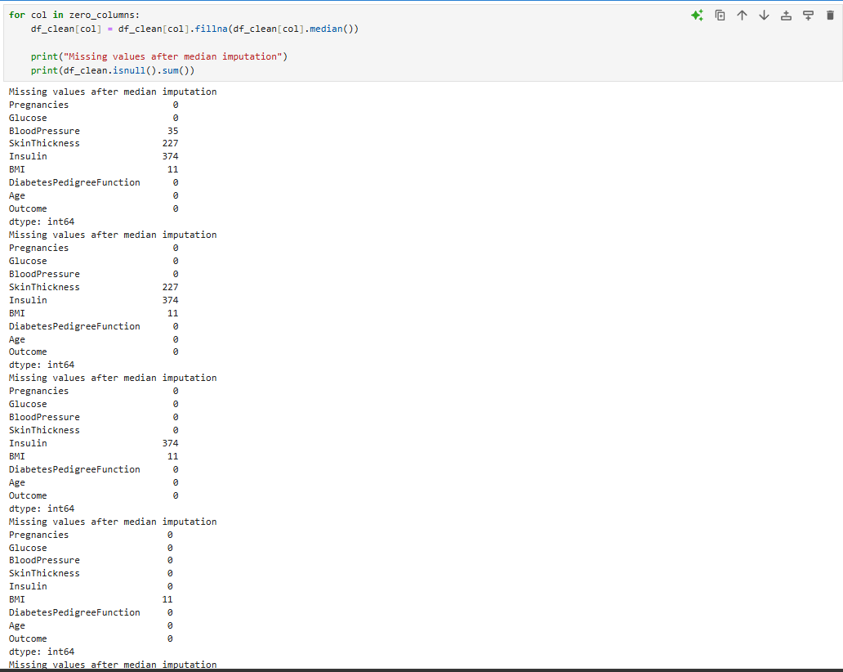To separate the input features (X) from the target variable (y) for applying the KNN algorithm.
To split the dataset into training and testing sets for the KNN model.
To check the class distribution in the training and testing datasets.
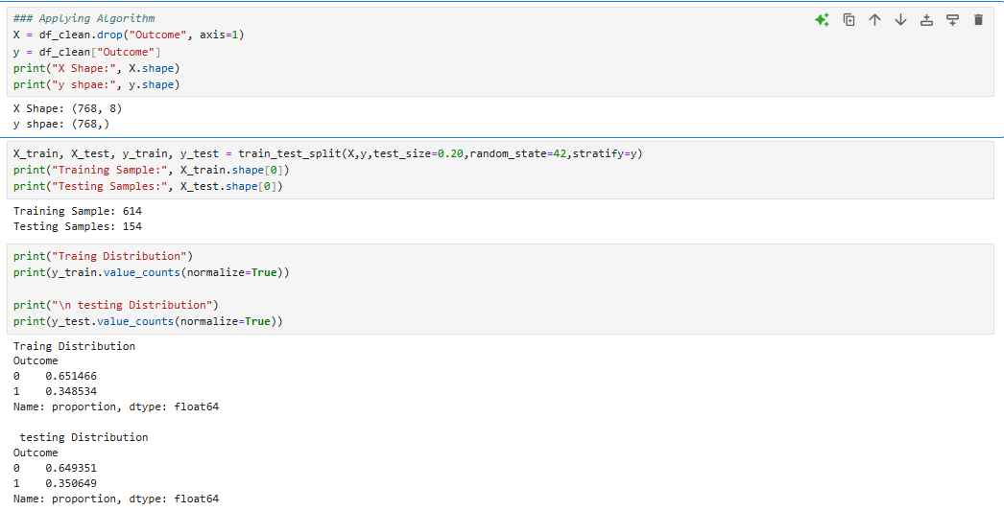

To standardize the features before applying the KNN algorithm.
To fit the scaler on the test data and transform it.
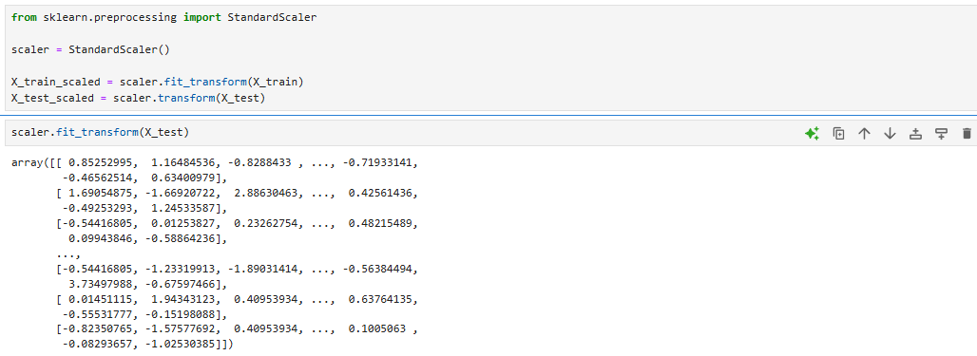
To split the dataset into training and testing sets, standardize the features using StandardScaler, and compare the mean and standard deviation of the original and scaled data.
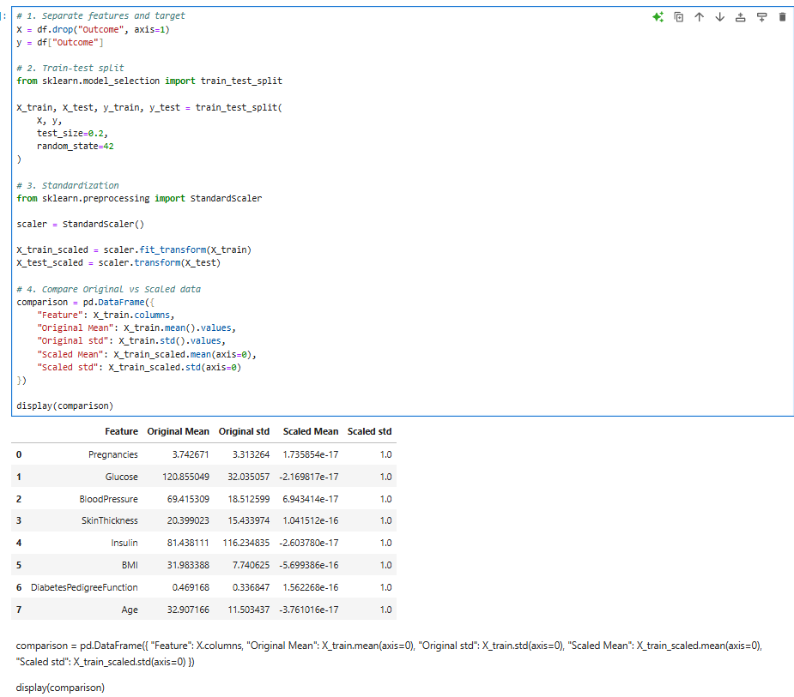
To create and train a KNN classification model using K = 5.
To calculate the probability of each test sample belonging to Outcome 1 (diabetes) using the trained KNN model.
To calculate and display the probability of Outcome 1 (diabetes) for the first 20 test samples using the trained KNN model.
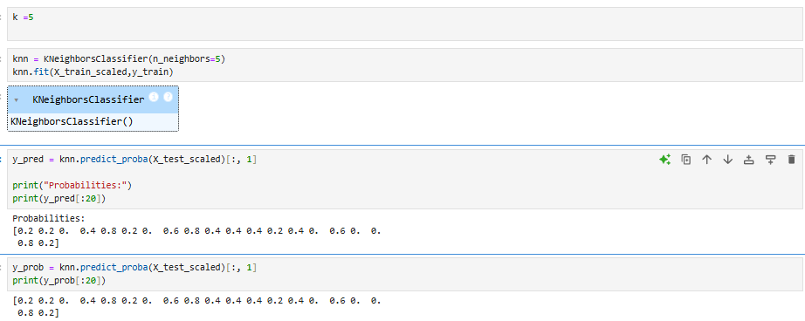
To train the KNN classifier with K = 5 and calculate its accuracy on the test data. 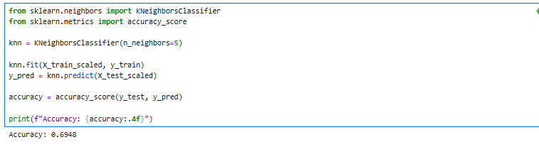
To calculate the precision of the KNN classifier, which shows how many predicted positive cases are actually positive.
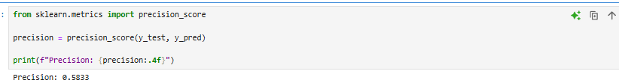
To calculate the recall of the KNN classifier, which shows how many actual positive cases were correctly identified.
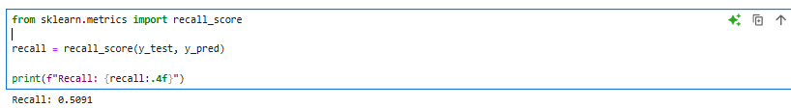
To calculate the F1-score, which combines precision and recall into a single performance measure.
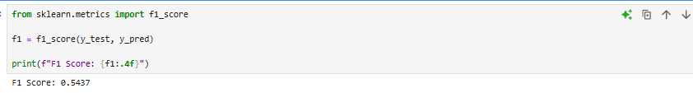
To create and display the confusion matrix, which shows the correct and incorrect predictions of the KNN classifier.
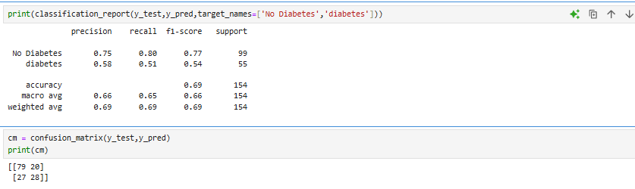
To visualize the confusion matrix as a heatmap, showing actual vs predicted diabetes classes.
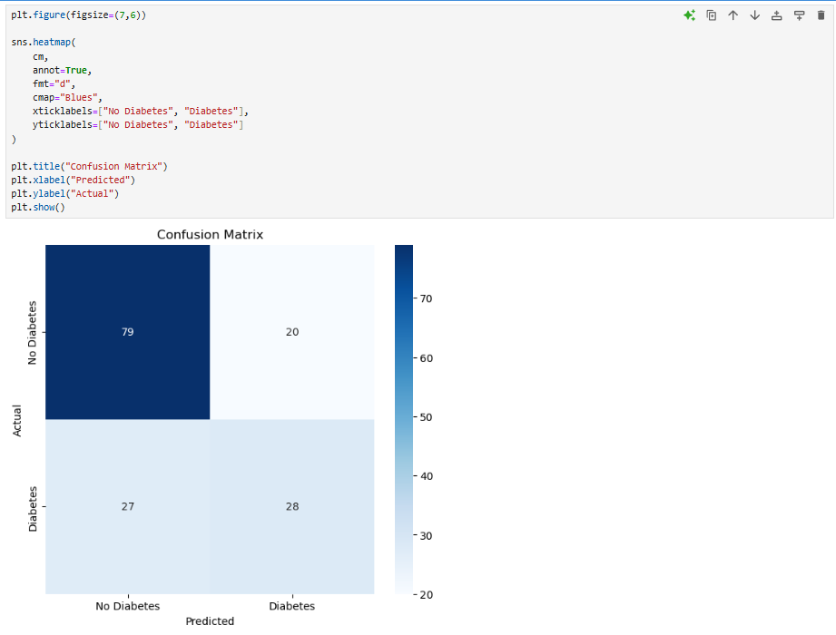To test different K values (1–30) and store the training and testing accuracy of the KNN model for each K.
To plot and compare the training and testing accuracy of KNN for different values of K (1–30).
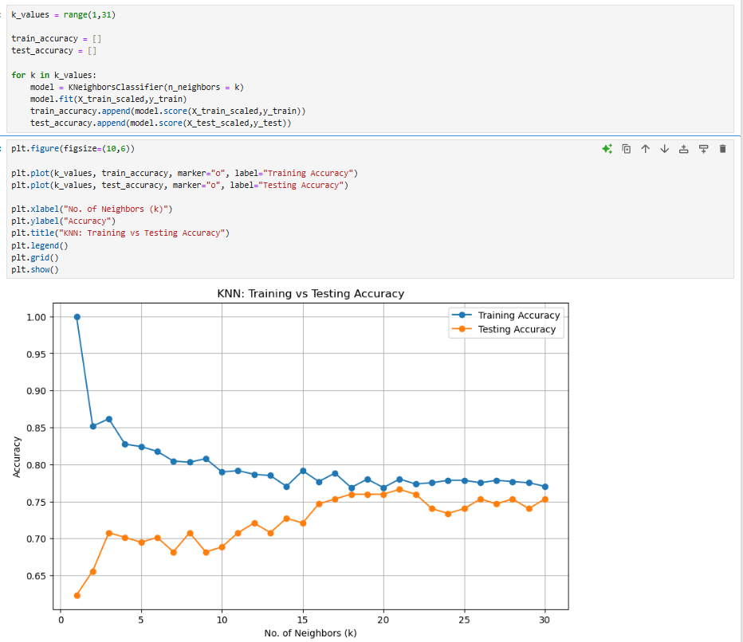To find the K value with the highest testing accuracy. 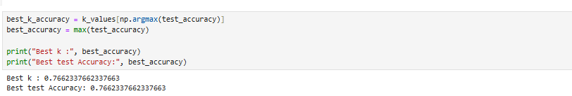To evaluate KNN for K = 1 to 30 using 5-fold stratified cross-validation and store the average accuracy for each K value. 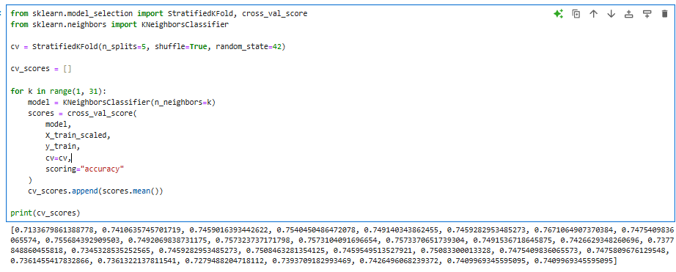
To find the best K value based on cross-validation accuracy. 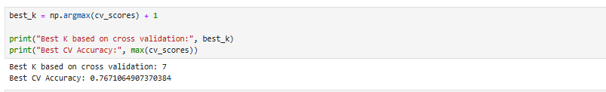To define different KNN hyperparameter values for GridSearchCV to find the best combination.
To use GridSearchCV to find the best KNN hyperparameters based on accuracy using 5-fold cross-validation.
